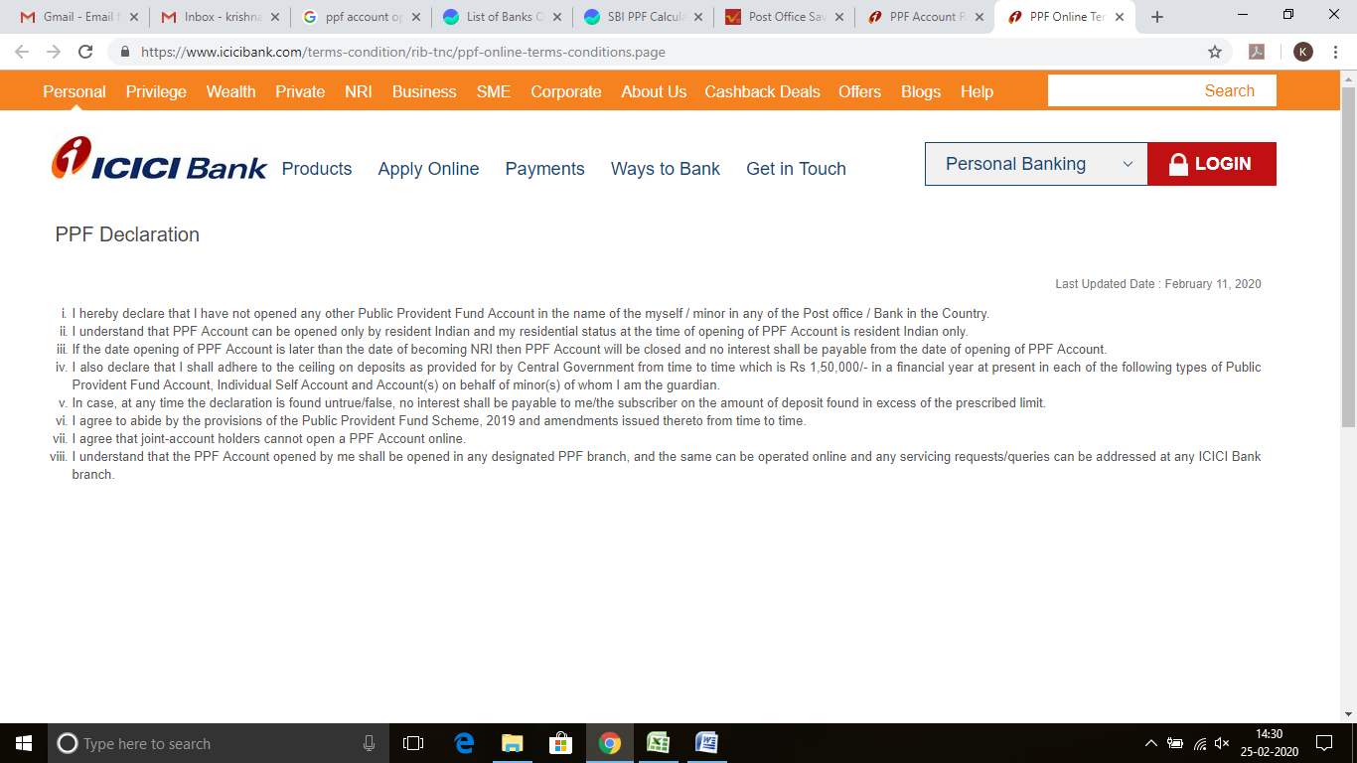

Screen Shot : 25-FEB-2020 14:30 PM Intellect Design Arena Limited, Siruseri, Chennai